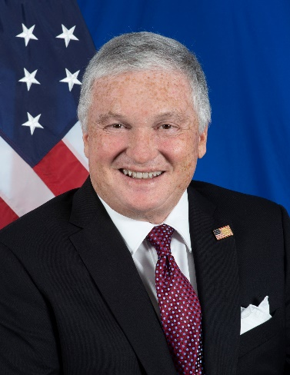
U.S. Ambassador to Romania, Adrian Zuckerman
Term of Appointment: 12/14/2019 to present

On December 14, 2019, Adrian Zuckerman assumed the duties of U.S. Ambassador to Romania. Ambassador Zuckerman is a prominent New York attorney and, prior to his appointment, was an equity partner in the real estate practice of the international law firm Seyfarth Shaw LLP. He successfully guided substantial individual and corporate clients through many sophisticated and complex transactions and litigations. Ambassador Zuckerman chaired a New York City civil court judicial screening panel and served as an arbitrator for the Real Estate Board of New York.

Ambassador Zuckerman immigrated to the United States from Romania at the age of 10 and is fluent in Romanian. Active in philanthropic and educational initiatives, He was a member of the board of Kids Corp., a non-profit organization that supports underprivileged children in Newark, New Jersey, and served on the alumni board of New York Law School.

At the Massachusetts Institute of Technology, Ambassador Zuckerman earned a B.S. in Life Sciences and a B.S. in management from MIT’s Sloan School of Management. He also received a J.D. from New York Law School.

